Land at Holden Fold, Darwen
Framework Travel Plan
200214/SK21876/FTP01(-00)

Contents
 |  | Page
1 | Introduction | 1
2 | Audit | 3
3 | Management | 11
4 | Toolkit | 11
5 | Monitoring | 14
6 | Implementation Plan | 15

Project | Document | Rev | Description | Authorised by | Signed | Date
SK21876 | FTP01 | -00 | - | L Speers | LGS | 14/02/2020

1 Introduction
  - SK has been appointed to prepare a Framework Travel Plan to support the planning application for a residential development on land at Holden Fold in Darwen.
  - A Transport Assessment (TA) has been prepared to accompany the outline planning application and this should be read in conjunction with this document for full details of the development impact and layouts. At the next stage in the Travel Plan development a standalone Travel Plan document will be prepared that contains relevant appendices and layouts.

Development Proposal Summary
  - The proposed layout is attached as Appendix A of the TA.
  - The proposal will deliver up to 453 dwellings in four phases between 2023 and 2026.
  - Vehicle access to the site will be provided at three locations, Roman Road, Holden Fold and Moor Lane.
  - The school site has an access from Holden Fold at western most end of the school frontage and a furthermore minor access arrangement at the eastern end. The western access has been reviewed and is not considered suitable for reuse due to visibility constraints. A location has been identified towards the eastern end of the Site frontage (in the vicinity of the existing secondary access) at which suitable standard residential access can be formed. This access is a priority layout with a 6m wide access road and 2m footways, as agreed with BwDC. Visibility splays of 2.4m x 43m are available. The proposed access is attached as Appendix E of the TA.
  - Extensive feasibility design work has been carried out at the Roman Road access in consultation with BwDC. Consideration has been given to both priority and mini-roundabout junction forms. Upon examination of the detailed capacity characteristics, it is noted that a mini-roundabout would result in unnecessary delay to the majority of traffic travelling north-south on Roman Road. A priority junction arrangement does not interfere with existing traffic movements on Roman Road and is shown to provide sufficient capacity for the development traffic. The Roman Road access layout is attached as Appendix E of the TA. This provides a simple priority arrangement with an access road of 6m and 2m footways. The proposal includes extending the 30mph speed limit north to accommodate the new built up frontage. Visibility splays are shown at 2.4m x 43m in line with the new speed limit of the road. The new speed limit is in line with surveyed speeds at this location. New footway is proposed to the south of the access junction within the existing highway to provide continuous pedestrian connection to the south on Roman Road.
  - As shown on Appendix E of the TA simple priority junction is also provided at Moor Lane. This access has a road width of 6m with 2m footways and visibility splay of 2.4m x 43m. Additional 2m footway is provided across the Site frontage to the west of the access junction on the site frontage.
  - The planning application is outline with all matters reserved except for access. This means that the details of the internal roads are a reserved matter. The routes will however be designed to an appropriate standard that provides provision for active modes, encourages low vehicle speeds and accommodates appropriate large vehicle. The existing PROW routes through the Site will be retained as part of the reserved matters layout. It is the intention to provide a vehicular connection between Roman Road and the Holden Fold access. The Moor Lane access will serve Plot D only, with only active mode connections to the rest of the Site and no vehicular through connection. Details of how the access strategy and phasing has been dealt with for the assessment are set out in Section 4 of the TA.
  - Parking will be provided for each dwelling in line with appropriate standards, including suitable provision for EV charging points.
  - The existing bus waiting area is reduced in length as part of the proposal and the lay-by retained for existing resident parking. The proposal includes a commitment to extend bus service TA5 to provide an hourly service provision and extend the service so that it accesses the Site at Roman Road via Higher Perry Street. The service will then egress the Site from Holden Fold and will continue on the existing route back to Darwen station via Anyon Street.
  - Bus stops and waiting infrastructure will be provided at suitable locations in the Site and bus stop infrastructure will be provided outside the Site on Holden Fold to the east of the access junction.
  - There is currently no cycle parking at Darwen station. The applicant has agreed to provide funding for five Sheffield stands (ten spaces).

Travel Plan Process
  - A Travel Plan is a tool for managing access to a site that aims to promote access by sustainable modes. It contains a package of measures designed to meet the objective to reduce car use generated from the site by supporting sustainable modes of transport and measures that will build on the location of a development site. In line with NPPF and DfT guidance, the measures adopted should be commensurate with the scale of impact from the development and the level of intervention required to encourage and support users to adopt opportunities for sustainable travel practices.
  - Within a Travel Plan there is a need to set objectives, targets and indicators, the purpose of which is to monitor change and review policies to meet the needs of the users of the site. Future management and monitoring mechanisms are set out in this document for adoption in the full Travel Plan.
  - The Travel Plan process is not a one-off, static event, but a constantly evolving strategy that should grow and adapt to meet the travel patterns and needs of the end users of the site. This Framework version of the Travel Plan is the first stage of the process and outlines the aims and objectives and sets the level of intervention required to encourage and support sustainable practices at the site.
  - The Framework Travel Plan draws on the following guidance and best practice:

- Department for Transport ‘Making Travel Plans Work’
- Department for Transport ‘Essential Guide to Travel Planning’

Benefits
  - Travel Plans result in a variety of benefits to users of a development and the wider community, including:

- Promoting active and healthy lifestyles
- Reducing demand for parking
- Reducing road safety and congestion issues
- Reducing carbon emissions and improving local air quality issues

Aims & Objectives
  - The aim of the final Travel Plan will be to reduce the number of single occupancy private car trips generated by the site and to support sustainable trip making.
  - To achieve these aims the following objectives have been set:

- To encourage residents to evaluate their travel patterns and needs
- To provide a toolkit in the Travel Plan to support sustainable trip making
- To set out a monitoring and management structure for the Travel Plan

Summary of Management Measures
  - The Framework Travel Plan includes measures under the following headings:

- Appointment of a Travel Co-ordinator
- Marketing & Promotion
- Resident Travel Packs
- Walking & Cycling
- Public Transport
- Carsharing
2 Audit
Site Location
  - Figure 2.1 shows the location of the site.

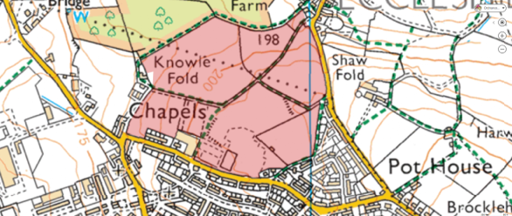
Figure 2.1: Site Location
  - The Site is approximately 14.3ha. The southern portion of the Site, bounding Holden Fold/Moor Lane, used to house the Darwen Moorland High School. Teaching at the school ceased in 2008 and the buildings were demolished in 2016. The remainder of the Site is farmland.
  - The Site is allocated for housing in Policy 16 of the Local Plan. The Local Plan states that the Site is a key housing allocation on the edge of the urban area.

Walking
  - The footways serving the Site are typical of its suburban location though, as noted above, there is no footway currently present on the northern side of Moor Lane, west of the former main access to the school. Pedestrian trips from the site will be principally concentrated on routes south, towards local amenities and Darwen town centre. These routes are residential in character providing a suitable environment for pedestrian trips.
  - There are a number of Public Right of Way (PROW) routes crossing the Site and running along the northern boundary. These are shown in Figure 2.2.

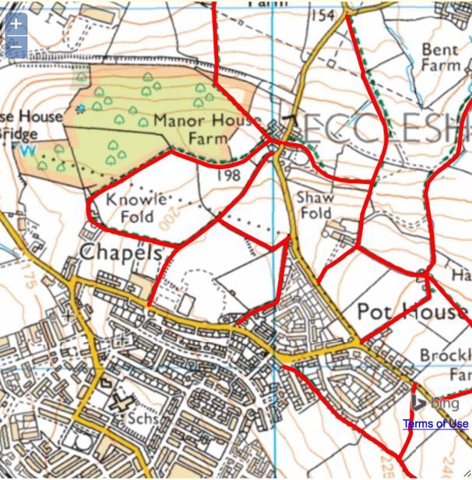
Figure 2.2: Public Right of Way Routes
[source: PROW June 2019]
  - Two-thirds of all journeys in the UK are under-five miles and short distance trips offer the greatest opportunity for changes in travel behaviour. The Department for Transport (DfT) best practice guidance states that walking has the potential to substitute for car trips under 2km, which equates to a 25-minute walk. CIHT provide further guidance on suitable walk distances, setting 800m as the preferred maximum to a town centre, 2km to employment/education facilities, and 1.2km to all other destinations.
  - Evidence that people will walk further than suggested by DfT is provided in the WYG Report (‘Accessibility – How Far Do People Walk and Cycle’) produced for CILT in 2015. This report refers to National Travel Survey (NTS) evidence for the UK, excluding London. It confirms the following 85%ile walk distances:

- All journeys – 1,930m
- Commuting – 2,400m
- Shopping – 1,600m
- Education – 3,200m/4,800m
- Personal business – 1,600m

  - The study concludes that a distance of 1,950m represents the recommended overall distance for the majority of land uses. This is in line with DfT advice. Figure 2.3 shows a 25-minute walk isochrone from the site, equating to a 2km walk distance based on an average walk speed of 80m/min.

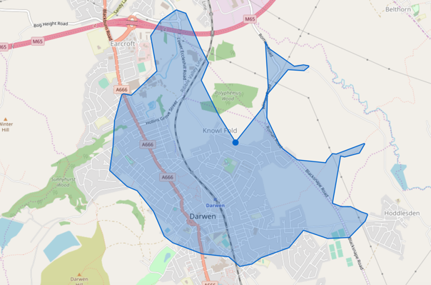
25mins
Figure 2.3: 25-Minute Walk Isochrone
  - Darwen town centre, including the train station and retail destinations, local primary and secondary facilities, and local retail on Olive Lane are within a 25-minute walk of the Site.
  - Table 2.1 provides details of the local amenities and services, and the distances to these facilities.

Type | Location | Distance (m) | Walk Time (mins)
Education | Darwen St James Primary | 800 | 10
Education | Sudell Primary | 1100 | 14
Education | Darwen Aldridge Academy | 1500 | 19
Community | Darwen Valley Community Centre | 1000 | 13
Community | Darwen Library Theatre | 1400 | 18
Community | Lower Chapel | 500 | 6
Community | St James Over Darwen Church | 650 | 8
F&B | Riverside Heights Restaurant | 1100 | 14
F&B | Wang's Takeaway | 550 | 7
F&B | Prince Of Wales | 850 | 11
Leisure | Darwen Leisure Centre & Swimming Pool | 1700 | 21
Leisure | Genjitsu Martial Arts | 900 | 11
Leisure | Olive Park Bowling Club | 1100 | 14
Retail | Pothouse Stores | 350 | 4
Retail | Ibrahim News | 1100 | 14
Retail | Asda | 1400 | 18
Retail | Lidl | 1400 | 18
Retail | Iceland | 1400 | 18
Personal Business | Barclays | 1400 | 18
Personal Business | Post Office | 1600 | 20
Personal Business | Post Box - Pothouse Stores | 350 | 4
Health | Dr A. Alam & Partner | 1200 | 15
Health | Darwen Dental Care | 1300 | 16
Health | Lloyds Pharmacy | 1400 | 18
Table 2.1: Access to Local Amenities & Services
  - Table 2.1 shows that the Site is well located to access numerous local amenities and services across Darwen. It is shown that the walk distances to the services are generally in line with the WYG/CILT walk distance study advice.
  - The Site is well located for access on foot and the pedestrian network creates a good basis for development trips by this mode.

Cycling
  - Figure 2.4 shows that there are no formal cycle routes directly serving the Site, but the residential character of the local roads makes these a suitable environment for cycle trips. These residential streets provide connections to on-road cycle routes serving the town centre.

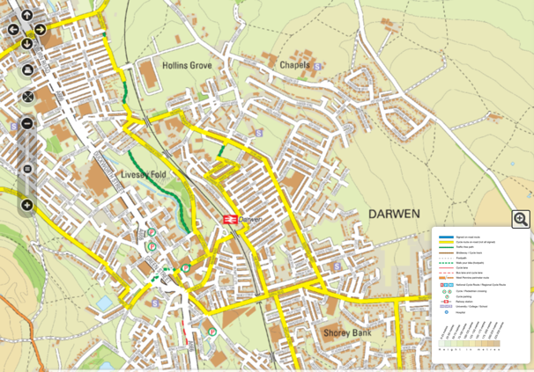
Figure 2.4: Existing Cycle Routes
[source: BwDC November 2019]
  - Access can be gained to the Weavers Wheel cycle route to the northwest of the Site. The Weavers Wheel route is a 26km route encircling Blackburn town centre that provides spurs radiating out to key employment and housing development locations.

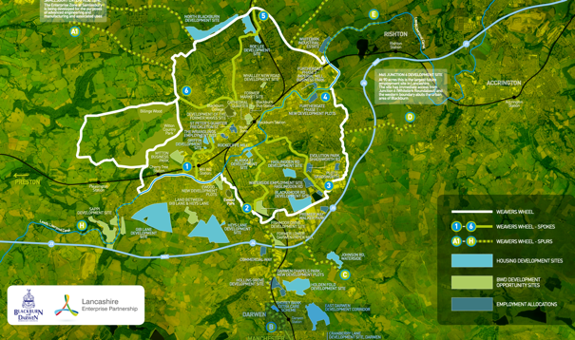
Figure 2.5: Weavers Wheel Cycle Route
[source: BWD Connect January 2020]
  - Cycling into Development Proposals’ states that cycling has the potential to substitute for car trips under five miles (8km). Figure 2.6 shows an 8km cycling catchment from the Site.

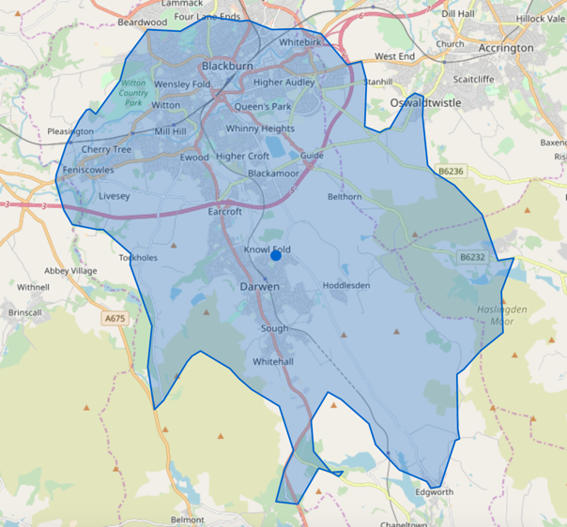
8km
Figure 2.6: 8km Cycle Catchment
  - Figure 2.6 shows that the Site is within an 8km cycle distance of all of Darwen, key areas of Blackburn, Oswaldtwistle and Edgworth.
  - The Site is well located for access by cycle, and the cycling network creates a good basis for development trips by this mode.

Public Transport
  - The public transport network serving the Site is shown on Figure 2.7.

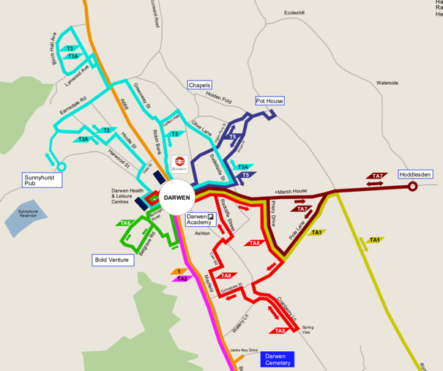

Figure 2.7: Public Transport Network

[source: BwDC Website December 2019]
  - There are existing bus stops on Holden Fold, including a long length of bus waiting area. Despite this there are currently no buses serving Holden Fold and Moor Lane and this infrastructure is associated with the previous use of part of the Site as a high school.
  - Bus service TA5 routes closest to the site and currently stops on Pot House Lane. This bus route is run by Travel Assist (a community transport service) and offers on a limited service provision as it operates throughout the day.

No. | Route | Monday – Friday  [Service Times from Darwen Station] |  |  |  | Saturday  [Service Times from Darwen Station]
TA5 | Pot House via Higher Perry Street | 10.00 | 11.00 | 13.30 | 14.30 | 9.30 | 13.00
Table 2.2: Travel to the Site from Darwen Station

No. | Route | Monday – Friday  [Service Times from Pot House Lane] |  |  |  | Saturday  [Service Times from Pot House Lane]
TA5 | Pot House via Anyon Street | 10.15 | 11.15 | 13.45 | 14.45 | 9.45 | 13.15
Table 2.3: Travel to the Site to Darwen Station

  - Darwen train station is a 15 minute walk from the Site. The station is served by trains to Blackburn, Bolton and Manchester that operate at a half hourly frequency throughout the week and hourly on Sunday.

Local Highway Network
  - The site is surrounded by unclassified roads (Moor Lane, Holden Fold and Pot House Lane) and Roman Road with a C classification.
  - The southern end of Knowle Lane, adjacent to the existing terraced houses, is adopted highway with an unclassified status. To the north of the existing terraced houses, Knowle Lane is unadopted. An unadopted track runs from the end of Knowle Lane along the northern boundary of the study area to Roman Road in the east.
  - The Site benefits from substantial sections of highway frontage on both Holden Road, Moor Lane and Roman Road.
  - Two existing vehicular accesses are present on Holden Fold that provide access to the historic site use. The western access comprises a substantial bellmouth arrangement with a 10m radius kerb leading into a 4.6m access road. The eastern access is more minor in nature, with tighter radii of circa 4m and leading to a 4.1m access road. An extensive layby is also present on the Holden Fold site frontage which historically provided space for school buses.
  - The carriageway width of Holden Fold varies between 6.5m and 7.3m across the main frontage of the Site (excluding the layby). Footways are generally present along both sides of the road, with the exception of the northern side to the east of the main site frontage, between the former main access point to the school and the western end of Moor Lane. The road is subject to a 30mph speed limit and street lighting is present.
  - Holden Fold becomes Moor Lane to the west of the main site frontage. At its western end, Moor Lane meets Goose House Lane and Chapels at a simple priority junction. Knowle Lane spurs off Moor Lane just north of this junction.
  - Goose House Lane continues north-west from Moor Lane, providing access to the A666 Blackburn Road (via Hollins Grove Street) and Junction 4 of the M65 (via Lower Eccleshill Road and Paul Rink Way). Access can be gained to the centre of Blackburn using either via Eccleshill Road continuing onto Greenbank Terrace or the A666 Blackburn Road.
  - Chapels provides access to A666 Blackburn Road and the centre of Darwen. Access can also be gained to the centre of Darwen using Oak Grove, to the east of the Holden Fold.
  - Continuing east on Holden Fold it becomes Pot House Lane which meets Roman Road at a ghost island priority junction. Roman Road routes north-south past the site providing access between Blackburn and Edgeworth. Roman Road is 5.5m to 6m wide and is subject to a 40mph speed limit along the site frontage. There are no footways or street lighting along Roman Road on the section fronting the site. Immediately south of the site the speed limit changes to 30mph. Footway on the western carriageway edge and street lighting are present from this point.
  - Continuing north on Roman Road it meets a crossroad junction formed with the B6231 Stopes Brow and B6231 Blackamoor Road. Access can be gained to areas surrounding Blackburn from this junction. Access can also be gained to Junction 5 of the M65 by traveling east on Blackamoor Road. The junction is scheduled for an improvement and is to be delivered as part of Phase 3 of the Growth Deal funding to improve traffic conditions to the south east of Blackburn. The junction proposal is attached as Appendix B of the TA.
  - Continuing south on Roman Road or via the residential routes to the south of the site and accessed from Chapels and Oak Grove, access can be gained to Marsh House Lane, Blacksnape Road and areas to the south of Darwen. Using the route via Oak Grove provides access to the new £3m distributor road (known as Ellison Fold Way) that extends from Ivinson Road in the north and Marsh House Lane in the south. The distributor road opened in March 2019.
  - Traffic surveys and a road safety assessment has been undertaken, and these are set out in Section 2 of the TA.

3 Management
Travel Co-ordinator
  - An effective Travel Plan needs a clear hierarchy of responsibility. The applicant has been closely involved in the development of the Framework and is committed its successful implementation on completion of the development.
  - Travel Co-ordinators play an important role in developing, implementing and managing Travel Plans. A sitewide Travel Plan Coordinator will be identified two months prior to occupation of the development and contact details provided to BwDC.
  - The Co-ordinator will form the main point of contact for site residents, nearby residents and BwDC. The Co-ordinator will also be responsible for raising awareness, marketing the Travel Plan and implementing the measures. The Co-ordinator will also be responsible for surveying the Plans effectiveness and assessing this against the stated objectives and targets.
  - In summary, the Travel Co-ordinator’s general role and responsibilities will include:

  - Implementing the Plan measures
  - Providing a point of contact for residents, the local community and BwDC
  - Publicising and raising awareness of local and national initiatives
  - Preparing and issuing the resident travel packs
  - Providing updates to residents on changes to local services and facilities
  - Monitoring and surveying travel patterns
  - Regularly reporting to BwDC

Funding Mechanisms
  - The applicant is committed to the implementation and successful delivery of the Travel Plan’s measures to meet the stated plan objectives.
  - The applicant has confirmed that it will fund the cost of time for the Travel Co-ordinator to implement Plan measures, respond to issues and undertake the annual survey and Plan review.
  - Under the current travel management arrangements, the following resources have been committed to the Plan:

- Implementing plan measures: 1 day per quarter
- Responding to staff/operator/guest issues: As required
- Annual monitoring review: 2 weeks per year

Handover Arrangements
  - The applicant, or their successor in title, will continue to have a regular overseeing role in the progress of the Plan and is committed to funding the resources required for its implementation. Should the applicant’s responsibility cease the responsibility for the Travel Plan will be handed over to the successor. Contact details for the successor will be provided to BwDC and the Travel Plan republished with new details in a timely manner to allow the Travel Plan to continue uninterrupted at the site. This will include new contact details for the Travel Coordinator should this role also change.

- Toolkit
Promotion & Marketing
  - Good communication is a vital component of the Travel Plan to ensure that residents are fully aware of the options available to them. Research undertaken by DfT shows that promotion and marketing of Travel Plans are one of the most important measures in encouraging people to travel sustainably and actively.
  - The Travel Co-ordinator will be responsible for marketing and promoting the Travel Plan. The following measures will be used to promote the Travel Plan:

- Travel packs for residents
- Promotion of local authority/local area travel campaigns/networks
- Promotion of the health and well-being benefits of active travel

  - All residents will be offered a copy of the Travel Plan on request and this can be issued to them electronically.

Benefits
  - The Travel Co-ordinator will also be responsible for making residents aware of the many benefits for travelling more sustainably:

- Improving health and wellbeing
- Saving money
- Reducing traffic congestion
- Increasing physical activity and fitness
- Improving air quality
- Reducing carbon emissions
- Meeting new people

  - The Travel Co-ordinator will promote these benefits and provide fun resources, such as the NHS’s Active 10 walking tracker, so that residents can track their progress and discover the real benefits of living sustainably.

Travel Packs
  - Travel packs will be prepared ready for first occupation of the development. The travel packs will provide:

- Travel Co-ordinator contact details
- Details of the Travel Forum
- Local area travel map
- Details of the benefits of active travel and weblink to fun resource such as the NHS’s Active10 walking tracker app
- Website links to BWD Connect Personal Journey Planner
- Website links to Traveline on-line and phone app journey planning software
- Website links to Trainline on-line and phone app journey planning software
- Website links to BWD Connect bus route information
- Website links to cycle route maps
- Website links to Cyclestreets journey planning software
- Website links to Blackburn town centre cycle parking locations
- Website links to Walkit journey planning software
- Website links to Walkbudi & Cyclebudi sharing schemes run by Liftshare
- Website links to cycle training and maintenance sessions run by BWD Connect
- Information on Shared Wheels car-sharing scheme

  - The travel pack will be prepared by the Travel Co-ordinator prior to occupation of the development and issued to all households.

Promotion of National Initiatives
  - The Travel Co-ordinator will promote local and national travel campaigns, including (but not limited to) the initiatives in Table 4.1.

Initiative | Date | Details | Contact
Big Pedal | March | UK's biggest cycle/scoot to school event organised by Sustrans | www.bigpedal.co.uk
National Walking Month | May | Living Streets' initiative to encourage people to take to their feet | www.livingstreets.org.uk
Walk to School/Work Week | May | Raising awareness of benefits for walking to school and work | www.livingstreets.org.uk
Work Wise Week/National Work from Home Day | May | Raising awareness of smarter working amongst employees and employers | www.workwiseuk.org
World Environment Day | June | A global day for positive environmental action | www.unep.org
Bike Week | June | Promoting how cycling can be part of everyday life | www.bikeweek.org.uk
Green Transport Week | June | Raising awareness of the impact of travel to make people think about the way they travel | www.eta.co.uk/trust/green-transport-week
National Ride to Work Day UK | June | Raising awareness of using scooters and motorcycles | www.ridetoworkweek.co.uk
Cycle to Work Day | Sept | Aims to encourage everyone to take two wheels to work for just one day | www.cycletoworkday.org
European Mobility Week | Sept | European festival promoting sustainable transport and raising awareness of issues with the private car | www.mobilityweek.eu
World Car Free Day | Sept | Encourage people to live a day without using their cars | www.worldcarfree.net
National Liftshare Week | Oct | Encourage people to car share | www.liftshare.com
National Commute Smart Week | Nov | Raising awareness of smarter working practices | www.workwiseuk.org
Road Safety Week | Nov | Annual community event aimed at inspiring people to promote road safety | www.roadsafetyweek.org.uk
Table 4.1: Local & National Travel Plan Campaigns
Walking & Cycling
  - Pedestrian access is provided from all vehicle access locations with 2m footways provided on either side of the access roads. A 2m footway is also provided to the south of the Roman Road access along the Site frontage to allow a connection to existing routes. A new length of footway is also provided to the west of the Moor Lane access junction. The existing PROW routes are retained throughout the Site.
  - While the application is outline and the on-site layout is a reserved matter, the on-site routes will be designed to foster pedestrian movements and reduce vehicle speeds in line with appropriate standards.
  - Appropriate levels of cycle parking will be provided on the Site and funding will be provided for new cycle parking at the station.
  - Information on local walking and cycling routes will be provided to residents in the travel pack. The elements that will be included in this information resource is as set out in the previous section.
  - BWD Connect offer free cycle training and maintenance sessions as part of its travel choices programme. Details will be provided to residents of this proposal.
  - Weblinks will be provided to residents so that they can familiarise themselves with the local initiatives on offer. These currently include led cycle rides and organised health walks.
  - Walkbudi and Cyclebudi schemes will be promoted to residents. These schemes are promoted by Liftshare and allow individuals to be matched so that they can travel together.
  - Residents will be made aware of tax exempt salary sacrifice cycle to work schemes, so that they can see if it is offered by their employer.

Public Transport
  - The existing bus waiting area is reduced in length as part of the proposal and the lay-by retained for existing resident parking. The proposal includes a commitment to extend bus service TA5 to provide an hourly service provision and extend the service so that it accesses the Site at Roman Road via Higher Perry Street. The service will then egress the Site from Holden Fold and will continue on the existing route back to Darwen station via Anyon Street.
  - Bus stops and waiting infrastructure will be provided at suitable locations in the Site and bus stop infrastructure will be provided outside the Site on Holden Fold to the east of the access junction.
  - In addition to maps providing details of existing public transport routes, the travel packs will include information relating to phone app and on-line journey planning information.
  - The Travel Co-ordinator will be responsible for maintaining regular contact with public transport operators to ensure that they are aware of any significant service changes in the area.
  - Residents will be made aware of Government supported employer season ticket schemes, so that they can see if it is offered by their employer.

Efficient Private Car Use
  - Residents who have no choice but to drive will be encouraged to do so efficiently by the promotion of the Shared Wheels Lancashire car share database.
  - The proposal will include appropriate levels of EV charging facilities.
  - Residents will be provided with information regarding local food retailers that provide home delivery.

5 Monitoring
Targets
  - Travel Plans include targets against which the success of the Plan can be monitored over time. Targets should be ambitious yet realistic. There are two main types of targets that are applicable to Travel Plans; action targets and quantitative targets.
  - In line with DfT guidance, action-based targets have been set for this first Travel Plan. These targets are based on the Travel Plan reaching set milestones or indicators. Action targets include the commitment to deliver a package of measures to help promote and encourage sustainable travel. The following action targets have been set for this stage in the Plan:

- Appoint Travel Co-ordinator
- Prepare travel packs

  - Quantifiable targets are also required that are specific, measurable, achievable and relevant (SMART). These targets are used to review and assess the impact of the Plan overtime. The targets will be set as part of the final Travel Plan for the site, following the first occupancy surveys.
  - Section 4 of the TA sets out the mode share of trips based on commuter travel data from the Census. This is replicated in Table 5.1.

Mode | Share
Public Transport | 8.4%
Motorcycle | 2.2%
Car D | 0.9%
Car P | 63.3%
Bike | 8.7%
Walk | 1.1%
Other | 15.4%
Table 51: Mode Share Data
[source: Nomis December 2019]
  - For the Framework the following SMART targets have been set, these will be reviewed when the final Travel Plan is prepared following the first surveys.

- Reduce single occupancy car trips by 5%

Surveys
  - Resident travel surveys will be undertaken within six months of the completion and occupation of phase 1. Consideration will be given to suitable incentives to increase the response rate as part of the survey.
  - The surveys will collect the following information:

- How residents usually travel to work/education
- How many cars and bikes are owned by each household
- How site users would like to travel

  - The surveys will provide a baseline against which the success of the measures can be assessed.
  - Following the first survey, travel surveys will be undertaken every two years for a total period of five years. Following the first surveys the final Travel Plan will be prepared and SMART targets set. After each survey period a short report will be issued for discussion with BwDC and new targets and measures set, if required.
  - A survey questionnaire will be prepared for inclusion in the final Travel Plan.

Dissemination
  - Information concerning the Travel Plan will be annually reported to BwDC following each travel survey and for the life of the Plan.

- Implementation Plan
  - Table 6.1 shows the implementation plan for the Travel Plan. This is an interim version for the first year of the Plan and will be updated and refined when the final Travel Plan is prepared.

Measure | Interventions | Timescale
Promotion / Marketing | Appoint Travel Co-ordinator | 2 months prior to occupation
 | Finalise Travel Packs | 1 month prior to occupation
 | Promote personalised journey planning websites & phone apps | On occupation
 | Email travel updates & local/annual campaigns | As required
Walking / Cycling | Provide pedestrian proposals & cycle storage | As part of the construction
 | Maintain PROW routes & provide funding for station cycle parking | As part of the construction
 | Provide walking & cycling route information | On occupation
 | Provide information on cycle training, forums & bike stores | On occupation
Public Transport | Provide information on public transport routes | On occupation
 | Provide funding for bus route extension | To be agreed
 | Contact bus operators regarding service changes | Quarterly
Efficient Vehicle | Provide EV charging points | On occupation
 | Promote Shared Wheels | On occupation
 | Promote home delivery services | On occupation
Monitoring | Finalise survey questionnaire | 1 month prior to occupation
 | Undertake first travel survey | Within 6 months of phase 1 occupation
 | Review Travel Plan targets | Within 8 months of phase 1 occupation
 | Prepare final Travel Plan | Within 8 months of phase 1 occupation
Table 6.1: Interim Implementation Plan (First Year)

