Land at Holden Fold, Darwen

Transport Assessment

200214/SK21876/TA01(-00)

Contents

1 Introduction 1
2 Existing Situation 1
3 Proposed Development 4
4 Development Trip Forecast 6
5 Accessibility 11
6 Impact 18
7 Conclusions 32

Appendices

A | Indicative Site Layout
B | Roman Road/Blackamoor Road Junction Improvement
C | Existing Traffic Flows
D | Roman Road ATC Data
E | Access Layouts
F | Swept Paths
G | Framework Travel Plan
H | TRICS Output – Residential
I | Census Output
J | Development Trip Distribution
K | Development Plot Flow Charts
L | Development Phase Flow Charts
M | TEMPRO Output
N | Background & Committed Development Flow Charts
O | Base & Development Flow Charts
P | Site Access Junction Operation – Roman Road
Q | Site Access Junction Operation – Holden Fold
R | Site Access Junction Operation – Moor Lane
S | Roman Road/Pot House Lane Operation
T | Roman Road/Blackamoor Road Operation
U | Roman Road/Marsh House Lane Operation
V | Ellison Way/Marsh House Lane Operation
W | Lower Eccleshill Road/Paul Rink Way Operation
X | A666 Blackburn Road/Hollins Grove Street Operation
Y | Goose House Lane/Hollins Grove Street Operation

Project | Document | Rev | Description | Authorised by | Signed | Date
SK21876 | TA01 | 00 | Draft | L Speers | LGS | 14/02/2020

1 Introduction
Background
  - SK has been instructed to prepare a Transport Assessment (TA) to accompany an outline planning application for a residential development on land at Holden Fold in Darwen. The proposal seeks to construct up to 453 dwellings and the indicative layout is attached as Appendix A.
  - The TA assesses the traffic, transport, safety and accessibility impact of the proposal. The TA has been prepared in accordance with the guidance set out in Blackburn with Darwen Council (BwDC) ‘Local Plan’ and ‘Residential Design Guidance’, and relevant national guidance as outlined in the National Planning Policy Framework (NPPF), Planning Practice Guidance (PPG) and Department for Transport (DfT) ‘Guidance on Transport Assessment’. The assessment also acknowledges the recent assessment guidance set out in the Chartered Institute of Transportation and Highways (CIHT) ‘Better Planning, Better Transport, Better Places’.
  - Scoping discussions have been held with BwDC and these discussions are reflected in the method set out in the TA. The TA also responds to BwDC’s comments set out in the November 2019 pre-application response.

2 Existing Situation
Site Location
  - Figure 2.1 shows the location of the Site.

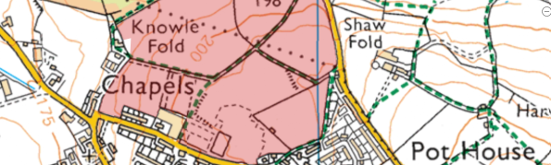
Figure 2.1: Site Location
  - The Site is approximately 14.3ha. The southern portion of the Site, bounding Holden Fold/Moor Lane, used to house the Darwen Moorland High School. Teaching at the school ceased in 2008 and the buildings were demolished in 2016. The remainder of the Site is farmland.
  - The Site is allocated for housing in Policy 16 of the Local Plan. The Local Plan states that the Site is a key housing allocation on the edge of the urban area.

Local Highway Network
  - Figure 2.2 shows the extent of adoption status of the roads surrounding the site. It shows that Moor Lane, Holden Fold and Pot House Lane are unclassified adopted roads and Roman Road is adopted highway with a C classification.
  - The southern end of Knowle Lane, adjacent to the existing terraced houses, is adopted highway with an unclassified status. To the north of the existing terraced houses, Knowle Lane is unadopted. An unadopted track runs from the end of Knowle Lane along the northern boundary of the study area to Roman Road in the east.
  - The Site benefits from substantial sections of highway frontage on both Holden Road, Moor Lane and Roman Road.
  - Two existing vehicular accesses are present on Holden Fold that provide access to the historic site use. The western access comprises a substantial bellmouth arrangement with a 10m radius kerb leading into a 4.6m access road. The eastern access is more minor in nature, with tighter radii of circa 4m and leading to a 4.1m access road. An extensive layby is also present on the Holden Fold site frontage which historically provided space for school buses.

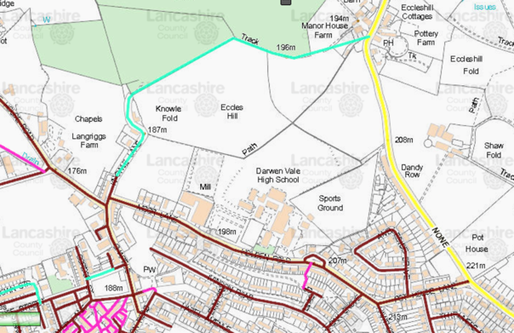
Figure 2.2: Adoption Status
[source: Mario Database November 2019]
  - The carriageway width of Holden Fold varies between 6.5m and 7.3m across the main frontage of the Site (excluding the layby). Footways are generally present along both sides of the road, with the exception of the northern side to the east of the main site frontage, between the former main access point to the school and the western end of Moor Lane. The road is subject to a 30mph speed limit and street lighting is present.
  - Holden Fold becomes Moor Lane to the west of the main site frontage. At its western end, Moor Lane meets Goose House Lane and Chapels at a simple priority junction. Knowle Lane spurs off Moor Lane just north of this junction.
  - Goose House Lane continues north-west from Moor Lane, providing access to the A666 Blackburn Road (via Hollins Grove Street) and Junction 4 of the M65 (via Lower Eccleshill Road and Paul Rink Way). Access can be gained to the centre of Blackburn using either via Eccleshill Road continuing onto Greenbank Terrace or the A666 Blackburn Road.
  - Chapels provides access to A666 Blackburn Road and the centre of Darwen. Access can also be gained to the centre of Darwen using Oak Grove, to the east of the Holden Fold.
  - Continuing east on Holden Fold it becomes Pot House Lane which meets Roman Road at a ghost island priority junction. Roman Road routes north-south past the site providing access between Blackburn and Edgeworth. Roman Road is 5.5m to 6m wide and is subject to a 40mph speed limit along the site frontage. There are no footways or street lighting along Roman Road on the section fronting the site. Immediately south of the site the speed limit changes to 30mph. Footway on the western carriageway edge and street lighting are present from this point.
  - Continuing north on Roman Road it meets a crossroad junction formed with the B6231 Stopes Brow and B6231 Blackamoor Road. Access can be gained to areas surrounding Blackburn from this junction. Access can also be gained to Junction 5 of the M65 by traveling east on Blackamoor Road. The junction is scheduled for an improvement and is to be delivered as part of Phase 3 of the Growth Deal funding to improve traffic conditions to the south east of Blackburn. The junction proposal is attached as Appendix B.
  - Continuing south on Roman Road or via the residential routes to the south of the site and accessed from Chapels and Oak Grove, access can be gained to Marsh House Lane, Blacksnape Road and areas to the south of Darwen. Using the route via Oak Grove provides access to the new £3m distributor road (known as Ellison Fold Way) that extends from Ivinson Road in the north and Marsh House Lane in the south. The distributor road opened in March 2019.

Road Safety
  - The DfT database has been reviewed for accidents occurring in the most recent five years available. The locations and severities of accidents on the roads directly serving the Site are shown in Figure 2.3.

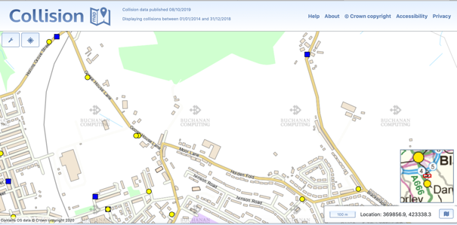
Figure 2.3: Accident Locations - Five Years
[source: DfT Collision Database January 2020]
  - The data shows that there has been one slight accident on Holden Fold during the period assessed. This accident occurred to the east of the site access in 2017 and did not involve pedestrians and cyclists.
  - A single accident has occurred at the junction of Pot House Lane/Roman Road. The accident occurred in 2016 and was classified as slight. The accident did not involve pedestrians or cyclists.
  - A single accident occurred to the north of the Site on Roman Road. The accident was classified as severe and occurred in 2015. The accident did not involve pedestrians or cyclists.
  - Three accidents have occurred at Goose House Lane. All were classified as slight and occurred in 2015, 2016 and 2018. The accidents did not involve pedestrians or cyclists.
  - The accident records on the adjacent streets do not indicate a prevalent safety problem or cause.

Study Area & Existing Traffic Flows
  - The agreed external study area for the purposes of the TA is set out below:

- Moor Lane/Chapels/Goose House Lane – priority junction
- Goose House Lane/Lower Eccleshill Road/Hollins Grove Street – priority junction
- Lower Eccleshill Road/Paul Rink Way/Greenbank Terrace – roundabout junction
- A666 Blackburn Road/Hollins Grove Street/Earnsdale Road – priority junction
- Pot House Lane/Roman Road – priority junction
- Stopes Brow/Roman Road/Blackamoor Road – signalised junction
- Roman Road/Marsh House Lane/Blacksnape Road – roundabout junction
- Marsh House Lane/Ellison Fold Way/Priory Drive – roundabout junction

  - AM and PM peak traffic surveys were undertaken at the junctions set out above on Wednesday 22nd May 2019. The surveys show that the AM peak hour occurs between 07:45 and 08:45, and the PM peak hour occurs between 16:30 and 17:30.
  - The survey data has been converted to passenger car units (PCU) in line with the following standard conversion factors:

- Bike: 0.2
- Motorbike: 0.4
- Car/LV: 1.0
- OGV1: 1.5
- OGV2: 2.3
- Bus: 2.0

  - The peak hour survey data is shown in the flow charts in Appendix C. The raw survey data is available electronically on request.

Roman Road Traffic Speeds
  - An Automatic Traffic Count (ATC) survey was undertaken on Roman Road between Tuesday 21st May and Friday 24th May 2019. The ATC data is attached as Appendix D, with a summary of the average and 85%ile road speeds provided in Table 2.1.

 | Average Speeds (mph) | 85%ile Speeds (mph)
Northbound | 28.5 | 31.9
Southbound | 25.1 | 28.3
Table 2.1: Roman Road – Road Speeds
  - The speed survey shows that vehicles are travelling below the 40mph speed limit.

3 Proposed Development
  - The indicative layout is attached as Appendix A.
  - The outline application seeks to deliver up to 453 dwellings in four phases as shown in Table 3.1.

 | Opening Year | Dwellings | Dwelling Type
Plot A | 2023 | 64 | Open Market
Plot B | 2023 | 55 | Open Market
Plot C | 2022 | 89 | Affordable
Plot D | 2025 | 82 | Open Market
Plot E | 2023 | 35 | Open Market
Plot F | 2026 | 75 | Open Market
Plot G | 2026 | 43 | Open Market
Total |  | 443
Table 3.1: Development Scale, Opening Years & Type

Phase Opening | Total Dwellings (cumulative)
2022 | 89
2023 | 243
2025 | 325
2026 | 443
Table 3.2: Cumulative Development Delivery Schedule
  - Vehicle access to the site will be provided at three locations, Roman Road, Holden Fold and Moor Lane.
  - The school site has an access from Holden Fold at the westernmost end of the school frontage, and a further more minor access arrangement at the eastern end. The western access has been reviewed and is not considered suitable for reuse due to visibility constraints. A location has been identified towards the eastern end of the Site frontage (in the vicinity of the existing secondary access) at which suitable standard residential access can be formed. This access is a priority layout with a 6m wide access road and 2m footways, as agreed with BwDC. Visibility splays of 2.4m x 43m are available. The proposed access is attached as Appendix E.
  - Extensive feasibility design work has been carried out at the Roman Road access in consultation with BwDC. Consideration has been given to both priority and mini-roundabout junction forms. Upon examination of the detailed capacity characteristics, it is noted that a mini-roundabout would result in unnecessary delay to the majority of traffic travelling north-south on Roman Road. A priority junction arrangement does not interfere with existing traffic movements on Roman Road and is shown to provide sufficient capacity for the development traffic. The Roman Road access layout is attached as Appendix E. This provides a simple priority arrangement with an access road of 6m and 2m footways. The proposal includes extending the 30mph speed limit north to accommodate the new built up frontage. Visibility splays are shown at 2.4m x 43m in line with the new speed limit of the road. The new speed limit is in line with surveyed speeds at this location. New footway is proposed to the south of the access junction within the existing highway to provide continuous pedestrian connection to the south on Roman Road.
  - As shown on Appendix E simple priority junction is also provided at Moor Lane. This access has a road width of 6m with 2m footways and visibility splay of 2.4m x 43m. Additional 2m footway is provided across the Site frontage to the west of the access junction on the site frontage.
  - Swept paths have been undertaken showing that large vehicles can access all of the proposed junctions. The swept paths are attached as Appendix F.
  - The planning application is outline with all matters reserved except for access. This means that the details of the internal roads are a reserved matter. The routes will however be designed to an appropriate standard that provides provision for active modes, encourages low vehicle speeds and accommodates appropriate large vehicle. The existing PROW routes through the Site will be retained as part of the reserved matters layout. It is the intention to provide a vehicular connection between Roman Road and the Holden Fold access. The Moor Lane access will serve Plot D only, with only active mode connections to the rest of the Site and no vehicular through connection. Details of how the access strategy and phasing has been dealt with for the assessment are set out in Section 4.
  - Parking will be provided for each dwelling in line with appropriate standards, including suitable provision for EV charging points.
  - The existing bus waiting area is reduced in length as part of the proposal and the lay-by retained for existing resident parking. The proposal includes a commitment to extend bus service TA5 to provide an hourly service provision and extend the service so that it accesses the Site at Roman Road via Higher Perry Street. The service will then egress the Site from Holden Fold and will continue on the existing route back to Darwen station via Anyon Street.
  - Bus stops and waiting infrastructure will be provided at suitable locations in the Site and bus stop infrastructure will be provided outside the Site on Holden Fold to the east of the access junction.
  - There is currently no cycle parking at Darwen station. The applicant has agreed to provide funding for five Sheffield stands (ten spaces).
  - A Framework Travel Plan has been prepared for the planning application. This sets out the principles of the transport strategy that will be used to assist residents to live sustainably, including infrastructure and promotional measures. The Framework Travel Plan includes management measures to be adopted on occupation of the site, an action plan, handover mechanisms, and monitoring mechanisms. The Framework Travel Plan is attached as Appendix G.

4 Trip Forecast

Development Phase Assessment Scenarios
  - The assessment considers future assessment scenarios that coincide with phase openings. Based on this, the assessment considers the following development flow scenarios:

- 2022 – Plot C
- 2023 – Plots A, B, C & E
- 2025 – Plots A, B, C, D & E
- 2026 – Plots A, B, C, D, E, F & G

Person Trip Generation
  - The person trip generation has been undertaken using the TRICS database. TRICS land use class 03 – Residential – A – Houses Privately Owned has been used for all the plots, even though 20% of the development will be affordable housing.
  - The output is attached as Appendix H, with a summary provided in Table 4.1. The person trip rates have been agreed with BwDC as part of the scoping discussions.

 | Person Trip Rate (per unit)
 | IN | OUT | TOTAL
AM | 0.200 | 0.804 | 1.004
PM | 0.592 | 0.250 | 0.842
Table 4.1: Person Rates

Development Mode Share
  - The Site is covered by the Census output areas shown in Figure 4.1.

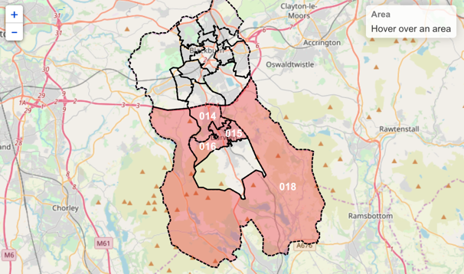
Figure 4.1: Census Zones – Mid Layer Output Areas
[source: Nomis December 2019]
  - The Site is covered by four output areas, Blackburn with Darwen (BwD) 014, 015, 016 and 018. Census data from these output areas have been reviewed for use in the assessment.
  - Mode share data for each output area has been taken from the Census. The Census output data is attached as Appendix I, with a summary provided in Table 4.2.

Mode | BwD 014 | BwD 015 | BwD 016 | BwD 018
Public Transport | 8.4% | 9.2% | 10.1% | 3.1%
Taxi | 2.2% | 2.5% | 2.0% | 0.4%
Motorcycle | 0.9% | 0.9% | 0.7% | 0.6%
Car D | 63.3% | 57.6% | 59.3% | 84.8%
Car P | 8.7% | 9.2% | 9.0% | 5.6%
Bike | 1.1% | 1.2% | 1.3% | 0.8%
Foot | 15.4% | 19.5% | 17.4% | 4.7%
Other | 0.1% | 0.1% | 0.2% | 0.0%
Table 4.2: Mode Share Data
[source: Nomis December 2019]
  - Latest professional institute guidance set out by the CIHT in the document ‘Better Planning, Better Transport, Better Places’ (2019), specifically advises against local authorities and transport professionals over forecasting traffic conditions as this leads to poor planning and infrastructure investment.
  - BwDC has advised that the highest car driver mode share should be used to allow a robust assessment. While this is agreed it is still important that the location used as the comparator broadly reflects the locational and transport characteristics of the Site, particularly in light of the new CIHT guidance.
  - Output area BwD 018 fails to do this as it covers largely rural and isolated village locations outside the built up area of Darwen. The Site is located on the edge of the current urban area and this will influence future travel practices so that it will have more in common with Census movements from the urban output areas (BwD 014, 015 and 016). To still ensure a robust assessment BwD 014 has been used as this has the highest car driver mode share of the urban modes. BwD 014 mode share data is highlighted in bold in Table 4.2.

Multimodal Trip Generation: Total Development
  - The Census mode share and person trip rates have been used to forecast the multimodal trips associated with the development.

 | Vehicles |  |  | Public Transport
 | IN | OUT | TOTAL | IN | OUT | TOTAL
AM | 59 | 236 | 295 | 7 | 30 | 37
PM | 174 | 74 | 248 | 22 | 9 | 31
 | Walking |  |  | Cycling
 | IN | OUT | TOTAL | IN | OUT | TOTAL
AM | 14 | 55 | 69 | 1 | 4 | 5
PM | 40 | 17 | 57 | 3 | 1 | 4
Table 4.3: Total Development

Residual Traffic Flows
  - Table 4.4 provides details of the residual traffic flows by plot delivery.

Opening | Plots | AM Peak Hour |  |  | PM Peak Hour
 |  | In | Out | Total | In | Out | Total
2022 | C | 12 | 47 | 59 | 35 | 15 | 50
2023 | A B E | 20 | 82 | 103 | 61 | 26 | 86
2025 | D | 11 | 44 | 55 | 32 | 14 | 46
2026 | F G | 16 | 63 | 79 | 46 | 20 | 66
Total | - | 59 | 236 | 295 | 174 | 74 | 248
Table 4.4: Residual Traffic Flows
  - Table 4.5 provides details of the cumulative residual traffic flows by opening year.

Opening | Plots | AM Peak Hour |  |  | PM Peak Hour
 |  | In | Out | Total | In | Out | Total
2022 | C | 12 | 47 | 59 | 35 | 15 | 50
2023 | A B C E | 32 | 130 | 162 | 95 | 40 | 136
2025 | A B C D E | 43 | 173 | 217 | 128 | 54 | 182
2026 | A B C D E F G | 59 | 236 | 295 | 174 | 74 | 248
Table 4.5: Residual Traffic Flows (Cumulative)

Trip Distribution & Assignment
  - Census origin-destination data has been used to establish the distribution of trips from the development. The Census data is attached as Appendix I.
  - Individual distributions have been developed for each access location. The trips have been assigned based on route planning software. Where more than one route is shown the trips have been assigned proportionally between the routes. Appendix J shows the access distribution assessment.
  - The assignment has been undertaken for each development plot, with access location as defined in Table 4.6.

 | Roman Road | Holden Fold | Moor Lane
Plot A | X
Plot B |  | X
Plot C |  | X
Plot D |  |  | X
Plot E | X
Plot F | X | X
Plot G | X | X
Table 4.6: Plot Access Location
  - As shown in Table 4.6, the defined access junction for each plot is based on the most convenient location for entering and leaving the Site. Plots F and G sit equidistance between the Roman Road and Holden Fold junctions. It is likely that residents in these areas will choose the access location that fits with onward direction of travel. Plots F and G will open in 2026, by this year Plot B will have been delivered and so residents will use either the Roman Road access or the Holden Fold access. The assessment assumes that Plots F and G will use both accesses with the decision based on onward travel direction.
  - Distribution proportion flow charts for each access are provided in Appendix J.

Development Flow Charts
  - Development flow charts for each plot are attached as Appendix K and for each phase are attached as Appendix L.

Traffic Growth
  - The observed traffic flows have been growthed to each phase opening year using TEMPRO locally adjusted NTEM factors. TEMPRO provides forecasts of background traffic flows for areas across the UK that take account of growth in car ownership, changes in trip ends, population growth and also scheduled growth in housing and employment developments. The following factors have been used for Darwen All Road Types:

- 2019 – 2022 AM: 1.0491
- 2019 – 2022 PM: 1.0499
- 2019 – 2023 AM: 1.0651
- 2019 – 2023 PM: 1.0663
- 2019 – 2025 AM: 1.0973
- 2019 – 2025 PM: 1.0991
- 2019 – 2026 AM: 1.1144
- 2019 – 2026 PM: 1.1164

  - The growth factors allow for local housing growth and so will already include traffic associated with the proposal. The use of the growth factors leads to an element of double counting.
  - BwDC has also requested that a five years post-final phase opening test also be included in the TA. This has been included in the TA as a sensitivity test because WEbTag guidance advises caution with regard the use of flat growth horizons over long periods of time as this type of assessment fails to acknowledge re-assignment effects and future changes in travel patterns. On this basis the 2031 forecast flows should be treated with some caution as they estimate a 20% increase in background traffic growth.
  - The following growth factors have been used for the sensitivity test:

- 2019 – 2031 AM: 1.1925
- 2019 – 2031 PM: 1.1973

  - The TEMPRO output is attached as Appendix M.
  - The growth has been applied to the existing traffic flows to create the background traffic growth scenarios attached as Appendix N.

Committed Developments
  - BwDC has advised that the committed Suez Energy from Waste proposals be included in the assessment. The Energy from Waste will expand Suez’s existing waste facility located off Lower Eccleshill Road. The additional Suez site flows have been taken from the TA prepared by RPS for the planning application (10/19/0495). The committed development flows are set out in Appendix N.
  - BwDC has advised of no other committed developments that require including in the assessments. The use of local TEMPRO factors replicates future housing growth in the area, including that associated with the development. This leads to an element of double-counting in the assessments.

Base Traffic Flows
  - The future year background traffic flows have been added to the committed development flows to create the base traffic flows for each assessment year. This is the situation that will occur if the development does not go ahead and is the baseline against which the development impact will be assessed.
  - The base traffic flows are shown in Appendix O.

Base & Development Traffic Flows
  - The future year base traffic flows have been added to the development flows to create the base with development traffic flows for each assessment year. The base and development traffic flows are shown in Appendix O.

5 Accessibility
Walking Accessibility
  - The footways serving the Site are typical of its suburban location though, as noted above, there is no footway currently present on the northern side of Moor Lane, west of the former main access to the school. Pedestrian trips from the site will be principally concentrated on routes south, towards local amenities and Darwen town centre. These routes are residential in character providing a suitable environment for pedestrian trips.
  - There are a number of Public Right of Way (PROW) routes crossing the Site and running along the northern boundary. These are shown in Figure 5.1.
  - Pedestrian access is provided from all vehicle access locations with 2m footways provided on either side of the access roads. A 2m footway is also provided to the south of the Roman Road access along the Site frontage to allow a connection to existing routes. A new length of footway is also provided to the west of the Moor Lane access junction. The existing PROW routes are retained throughout the Site.
  - While the application is outline and the on-site layout is a reserved matter, the on-site routes will be designed to foster pedestrian movements and reduce vehicle speeds in line with appropriate standards.

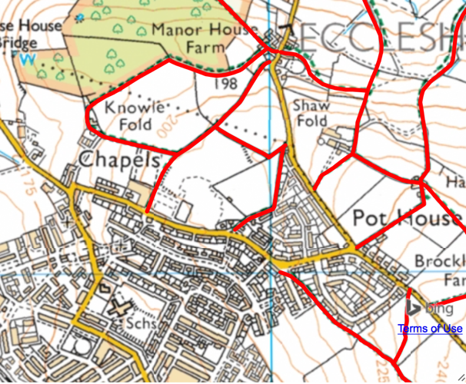
Figure 5.1: Public Right of Way Routes
[source: PROW June 2019]
  - Two-thirds of all journeys in the UK are under-five miles and short distance trips offer the greatest opportunity for changes in travel behaviour. The Department for Transport (DfT) best practice guidance states that walking has the potential to substitute for car trips under 2km, which equates to a 25-minute walk. CIHT provide further guidance on suitable walk distances, setting 800m as the preferred maximum to a town centre, 2km to employment/education facilities, and 1.2km to all other destinations.
  - Evidence that people will walk further than suggested by DfT is provided in the WYG Report (‘Accessibility – How Far Do People Walk and Cycle’) produced for CILT in 2015. This report refers to National Travel Survey (NTS) evidence for the UK, excluding London. It confirms the following 85%ile walk distances:

- All journeys – 1,930m
- Commuting – 2,400m
- Shopping – 1,600m
- Education – 3,200m/4,800m
- Personal business – 1,600m

  - The study concludes that a distance of 1,950m represents the recommended overall distance for the majority of land uses. This is in line with DfT advice.
  - Figure 5.2 shows a 25-minute walk isochrone from the Site, equating to a 2km walk distance based on an average walk speed of 80m/min.

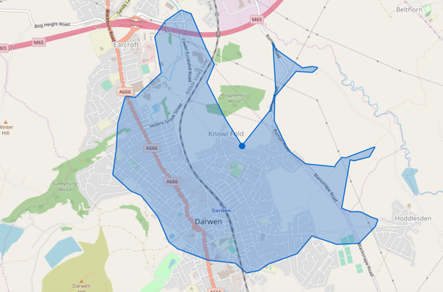
25mins
Figure 5.2: 25-Minute Walk Isochrone
  - Darwen town centre, including the train station and retail destinations, local primary and secondary facilities, and local retail on Olive Lane are within a 25-minute walk of the Site.
  - Table 5.1 provides details of the local amenities and services, and the distances to these facilities.

Type | Location | Distance (m) | Walk Time (mins)
Education | Darwen St James Primary | 800 | 10
Education | Sudell Primary | 1100 | 14
Education | Darwen Aldridge Academy | 1500 | 19
Community | Darwen Valley Community Centre | 1000 | 13
Community | Darwen Library Theatre | 1400 | 18
Community | Lower Chapel | 500 | 6
Community | St James Over Darwen Church | 650 | 8
F&B | Riverside Heights Restaurant | 1100 | 14
F&B | Wang's Takeaway | 550 | 7
F&B | Prince Of Wales | 850 | 11
Leisure | Darwen Leisure Centre & Swimming Pool | 1700 | 21
Leisure | Genjitsu Martial Arts | 900 | 11
Leisure | Olive Park Bowling Club | 1100 | 14
Retail | Pothouse Stores | 350 | 4
Retail | Ibrahim News | 1100 | 14
Retail | Asda | 1400 | 18
Retail | Lidl | 1400 | 18
Retail | Iceland | 1400 | 18
Personal Business | Barclays | 1400 | 18
Personal Business | Post Office | 1600 | 20
Personal Business | Post Box - Pothouse Stores | 350 | 4
Health | Dr A. Alam & Partner | 1200 | 15
Health | Darwen Dental Care | 1300 | 16
Health | Lloyds Pharmacy | 1400 | 18
Table 5.1: Access to Local Amenities & Services
  - Table 5.1 shows that the Site is well located to access numerous local amenities and services across Darwen. It is shown that the walk distances to the services are generally in line with the WYG/CILT walk distance study advice.
  - The Site is well located for access on foot and the pedestrian network creates a good basis for development trips by this mode.

Cycling Accessibility
  - The application is outline with all matters reserved except access. While details of the on-site layout are a reserved matter, future routes will be delivered across the Site that provide a conducive environment for cycle trips. The applicant has also agreed to fund five Sheffield cycle stands at Darwen station.
  - Figure 5.3 shows that there are no formal cycle routes directly serving the Site, but the residential character of the local roads makes these a suitable environment for cycle trips. These residential streets provide connections to on-road cycle routes serving the town centre.

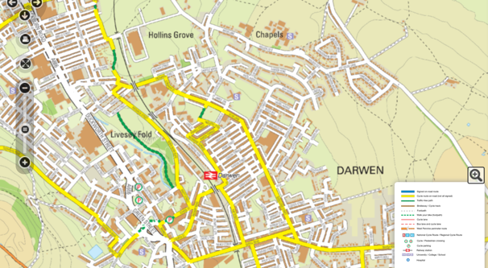
Figure 5.3: Existing Cycle Routes
[source: BwDC November 2019]
  - Access can be gained to the Weavers Wheel cycle route to the northwest of the Site. The Weavers Wheel route is a 26km route encircling Blackburn town centre that provides spurs radiating out to key employment and housing development locations.

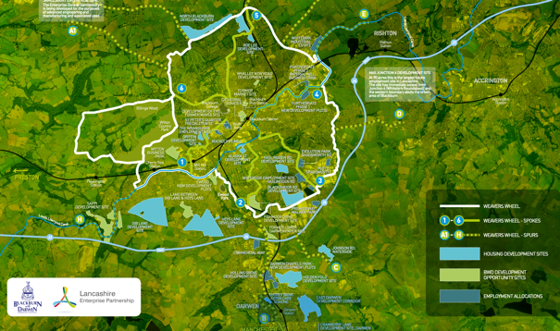
Figure 5.4: Weavers Wheel Cycle Route
[source: BWD Connect January 2020]
  - Cycling into Development Proposals’ states that cycling has the potential to substitute for car trips under five miles (8km). Figure 5.5 shows an 8km cycling catchment from the Site.

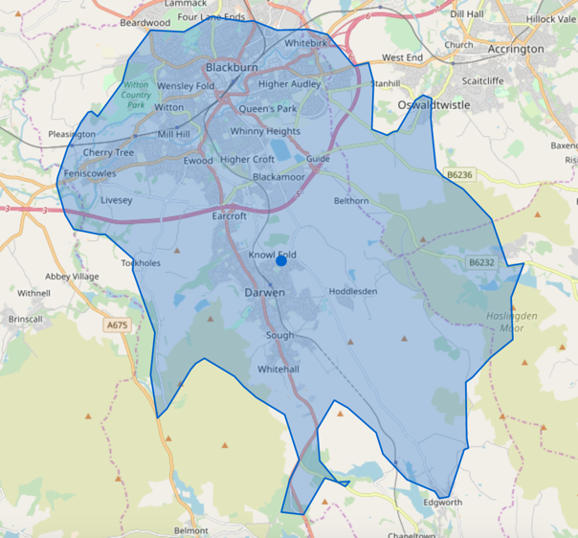
8km
Figure 5.5: 8km Cycle Catchment
  - Figure 5.5 shows that the Site is within an 8km cycle distance of all of Darwen, key areas of Blackburn, Oswaldtwistle and Edgworth.
  - The Site is well located for access by cycle, and the cycling network creates a good basis for development trips by this mode.

Public Transport
  - The public transport network serving the Site is shown on Figure 5.6.

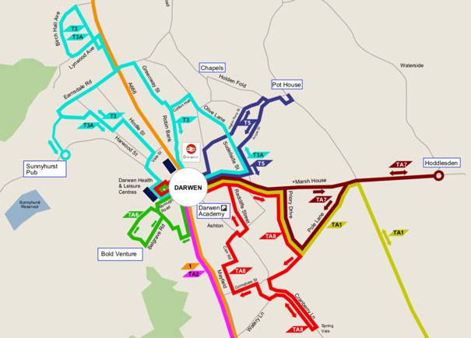

Figure 5.6: Public Transport Network

[source: BwDC Website December 2019]
  - There are existing bus stops on Holden Fold, including a long length of bus waiting area. Despite this there are currently no buses serving Holden Fold and Moor Lane and this infrastructure is associated with the previous use of part of the Site as a high school. The existing bus waiting area is reduced in length as part of the proposal and the lay-by retained for existing resident parking.
  - Bus service TA5 routes closest to the site and currently stops on Pot House Lane. This bus route is run by Travel Assist (a community transport service) and offers on a limited service provision as it operates throughout the day.

No. | Route | Monday – Friday  [Service Times from Darwen Station] |  |  |  | Saturday  [Service Times from Darwen Station]
TA5 | Pot House via Higher Perry Street | 10.00 | 11.00 | 13.30 | 14.30 | 9.30 | 13.00
Table 5.2: Travel to the Site from Darwen Station

No. | Route | Monday – Friday  [Service Times from Pot House Lane] |  |  |  | Saturday  [Service Times from Pot House Lane]
TA5 | Pot House via Anyon Street | 10.15 | 11.15 | 13.45 | 14.45 | 9.45 | 13.15
Table 5.3: Travel to the Site to Darwen Station

  - Darwen train station is a 15 minute walk from the Site. The station is served by trains to Blackburn, Bolton and Manchester that operate at a half hourly frequency throughout the week and hourly on Sunday.
  - The proposal includes a commitment to extend bus service TA5 to provide an hourly service provision and extend the service so that it accesses the Site at Roman Road via Higher Perry Street. The service will then egress the Site from Moor Lane East/Holden Fold and will continue on the existing route back to Darwen station via Anyon Street.
  - Bus stops and waiting infrastructure will be provided at suitable locations in the Site and bus stop infrastructure will be provided outside the Site on Holden Fold to the east of the access junction.

Potential for Multimodal Trips
  - The Site offers opportunities for multimodal sustainable trips. This could take the form of a cycle-rail trip by cycling circa five minutes to Darwen station and then using the train service. Walking to the station may also be an option for some residents. The 15 minute walk time to the train station is at the upper limit of how far some residents will walk, it will not be a deterrent to many residents. The health benefits of walking and cycling to the station will be promoted to residents using the Travel Plan. Funding will be provided for cycle parking at the station.
  - Access can also be gained to the train station using bus service TA5, the journey time is 14 minutes. This will also be promoted through the Travel Plan.

Sustainable Transport Strategy
  - It is demonstrated that there are a number of useful amenities within a walkable distance of the Site. This includes education, health, retail and leisure destinations.
  - Pedestrian and cycle access to the Site is good with local streets providing a suitable environment for active modes.
  - The Site is served by bus route TA5 that provides a limited service to/from Darwen town centre. This bus service can be used to access train services from Darwen Station. Darwen Station can also be accessed by bike in four minutes and foot in 15 minutes.
  - To further enhance the sustainable credentials of the development the following measures are included:

- Site location accessible to established local services
- On-site highway routes and access points that encourage and support active travel movements
- Site frontage footway improvements
- Funding for cycle parking at the station
- Extension to bus route TA5
- Provision of appropriate bus waiting infrastructure
- Retention of existing PROW routes
- Adoption of a site wide Travel Plan
- Promotion of car-sharing for essential car users
- EV charging technology

  - A Travel Plan will be adopted for the Site that includes measures to support and promote sustainable living practices. A Travel Plan Co-ordinator will be appointed on occupation of the development to oversee and manage the Plan. The Travel Plan promotes and supports movements by sustainable modes and will include measures to encourage efficient vehicle use, such as car sharing and home food shopping deliveries. The proposal will provide appropriate levels of EV charging infrastructure.

Policy Compliance
  - Paragraph 92 of NPPF (2019) states that planning decisions should ensure an integrated approach to considering the location of housing, economic uses and community facilities and services. This is further supported by paragraphs 103 and 104, which support developments in locations which have access to a mix of uses to minimise the number and length of journeys needed. Policy CS22 of the Core Strategy supports development that is located so to minimise the need to travel.
  - The Site is shown to be well placed to meet the requirements of local and national policy.

- Impact
Preamble
  - The impact assessment has used traditional assessment methods using historic data. The development forecast does not allow for the impact the introduction of the new bus service will have on reducing car trips. Further, the use of TEMPRO growth has the effect of double-counting background traffic growth as TEMPRO will include traffic forecasts that relate to the increase in housing in the area, including the proposed development. The use of a flat growth profile such as TEMPRO over a long assessment period also leads to over-forecasting effects that should be borne in mind when examining the results below.
  - Appendix L shows the change in traffic at each junction in the study area. This shows that in 2022 (the opening of Plot C) will not lead to an increase in traffic above 30 vehicles per hour in either peak. While the study area junctions have been modelled for this scenario and output presented in the relevant appendices, the impact on operation in 2022 is not set out in the main text.
  - All other phase scenario modelling outputs are summarised below.

Site Access Junction – Roman Road
  - PICADY has been used to assess the operation of the Roman Road site access junction. The modelling is attached as Appendix P with a summary of the operation provided in Table 6.1.

 | AM Peak |  | PM Peak
2023 | RFC | Queue | RFC | Queue
Site Access | 0.167 | 0.2 | 0.043 | 0.0
Roman Road N | 0.017 | 0.0 | 0.054 | 0.1
2025 | RFC | Queue | RFC | Queue
Site Access | 0.171 | 0.2 | 0.043 | 0.0
Roman Road N | 0.018 | 0.0 | 0.056 | 0.1
2026 | RFC | Queue | RFC | Queue
Site Access | 0.281 | 0.4 | 0.067 | 0.1
Roman Road N | 0.042 | 0.1 | 0.127 | 0.3
2031 | RFC | Queue | RFC | Queue
Site Access | 0.298 | 0.4 | 0.069 | 0.1
Roman Road N | 0.044 | 0.1 | 0.135 | 0.3
Table 6.1: Roman Road Site Access Operation
  - The assessment shows that the Roman Road access junction will operate well within capacity in all scenarios tested with minimal queuing.

Site Access Junction – Holden Fold
  - PICADY has been used to assess the operation of the Holden Fold site access junction. The modelling is attached as Appendix Q with a summary of the operation provided in Table 6.2.

 | AM Peak |  | PM Peak
2023 | RFC | Queue | RFC | Queue
Site Access | 0.156 | 0.2 | 0.051 | 0.1
Holden Road E | 0.017 | 0.0 | 0.045 | 0.1
2025 | RFC | Queue | RFC | Queue
Site Access | 0.158 | 0.2 | 0.053 | 0.1
Holden Road E | 0.017 | 0.0 | 0.049 | 0.1
2026 | RFC | Queue | RFC | Queue
Site Access | 0.211 | 0.3 | 0.071 | 0.1
Holden Road E | 0.023 | 0.0 | 0.069 | 0.1
2031 | RFC | Queue | RFC | Queue
Site Access | 0.214 | 0.3 | 0.072 | 0.1
Holden Road E | 0.024 | 0.0 | 0.071 | 0.1
Table 6.2: Holden Fold Site Access Operation
  - The assessment shows that the Holden Fold access junction will operate well within capacity in all scenarios tested with minimal queuing.

Site Access Junction – Moor Lane
  - PICADY has been used to assess the operation of the Moor Lane site access junction. The modelling is attached as Appendix R with a summary of the operation provided in Table 6.3.

 | AM Peak |  | PM Peak
2025 | RFC | Queue | RFC | Queue
Site Access | 0.095 | 0.1 | 0.033 | 0.0
Moor Lane E | 0.009 | 0.0 | 0.025 | 0.0
2026 | RFC | Queue | RFC | Queue
Site Access | 0.096 | 0.1 | 0.033 | 0.0
Moor Lane E | 0.009 | 0.0 | 0.025 | 0.0
2031 | RFC | Queue | RFC | Queue
Site Access | 0.097 | 0.1 | 0.034 | 0.0
Moor Lane E | 0.009 | 0.0 | 0.025 | 0.0
Table 6.3: Moor Lane Site Access Operation
  - The assessment shows that the Moor Lane access junction will operate well within capacity in all scenarios tested with minimal queuing.

Roman Road – Pothouse Lane
  - PICADY has been used to assess the operation of the Roman Road/Pot House Lane junction. The modelling is attached as Appendix S with a summary of the operation provided in Tables 6.4 and 6.5.

 | AM Peak |  | PM Peak
2023 | RFC | Queue | RFC | Queue
Pot House Lane RT | 0.469 | 0.9 | 0.206 | 0.3
Pot House Lane LT | 0.488 | 0.9 | 0.504 | 1.0
Roman Road N | 0.200 | 0.2 | 0.356 | 0.5
2025 | RFC | Queue | RFC | Queue
Pot House Lane RT | 0.504 | 1.0 | 0.221 | 0.3
Pot House Lane LT | 0.527 | 1.1 | 0.532 | 1.1
Roman Road N | 0.208 | 0.3 | 0.370 | 0.6
2026 | RFC | Queue | RFC | Queue
Pot House Lane RT | 0.523 | 1.1 | 0.228 | 0.3
Pot House Lane LT | 0.545 | 1.1 | 0.548 | 1.2
Roman Road N | 0.215 | 0.3 | 0.375 | 0.6
2031 | RFC | Queue | RFC | Queue
Pot House Lane RT | 0.654 | 1.8 | 0.280 | 0.4
Pot House Lane LT | 0.672 | 1.9 | 0.629 | 1.7
Roman Road N | 0.237 | 0.3 | 0.409 | 0.7
Table 6.4: Roman Road/Pot House Lane Operation – Base Scenarios

 | AM Peak |  | PM Peak
2023 | RFC | Queue | RFC | Queue
Pot House Lane RT | 0.545 | 1.2 | 0.246 | 0.3
Pot House Lane LT | 0.572 | 1.3 | 0.537 | 1.1
Roman Road N | 0.241 | 0.3 | 0.383 | 0.6
2025 | RFC | Queue | RFC | Queue
Pot House Lane RT | 0.636 | 1.6 | 0.273 | 0.4
Pot House Lane LT | 0.664 | 1.8 | 0.579 | 1.3
Roman Road N | 0.255 | 0.3 | 0.406 | 0.7
2026 | RFC | Queue | RFC | Queue
Pot House Lane RT | 0.747 | 2.7 | 0.291 | 0.4
Pot House Lane LT | 0.766 | 3.0 | 0.609 | 1.5
Roman Road N | 0.260 | 0.4 | 0.416 | 0.7
2031 | RFC | Queue | RFC | Queue
Pot House Lane RT | 0.990 | 12.6 | 0.372 | 0.6
Pot House Lane LT | 0.971 | 9.4 | 0.702 | 2.2
Roman Road N | 0.286 | 0.4 | 0.449 | 0.8
Table 6.5: Roman Road/Pot House Lane Operation – With Development Scenarios
  - The assessment shows that the junction will continue to operate within capacity in all scenarios. The junction is forecast to be approaching capacity in the AM peak in 2031 with the inclusion of the development. However, the with development flows are a worst-case estimate and this should be borne in mind when reviewing the results.

Roman Road – Blackamoor Road
  - LINSIG has been used to assess the operation of the Roman Road/Blackamoor Road junction. The junction has been assessed with the proposed improvement associated with the Blackamoor Link Road in place. The improvement scheme closes the eastern arm of the junction and diverts Blackamoor Road (East) traffic movements to the new link road. The modelling is attached as Appendix T with a summary of the operation provided in Tables 6.6 and 6.7.

 | AM Peak |  | PM Peak
2023 | DoS | MMQ | DoS | MMQ
Roman Road S Left | 11.2% | 1.2 | 24.7% | 3.0
Roman Road S Ahead | 79.1% | 18.1 | 57.8% | 10.4
Blackamoor Road | 94.8% | 14.3 | 92.2% | 13.6
Roman Road N | 98.3% | 28.9 | 94.4% | 29.1
2025 | DoS | MMQ | DoS | MMQ
Roman Road S Left | 11.1% | 1.2 | 25.0% | 3.0
Roman Road S Ahead | 78.2% | 18.1 | 58.4% | 10.7
Blackamoor Road | 103.0% | 21.7 | 99.7% | 19.0
Roman Road N | 102.9% | 39.6 | 98.4% | 36.4
2026 | DoS | MMQ | DoS | MMQ
Roman Road S Left | 11.2% | 1.2 | 25.9% | 3.1
Roman Road S Ahead | 79.5% | 18.4 | 60.6% | 11.3
Blackamoor Road | 104.7% | 24.2 | 101.3% | 21.1
Roman Road N | 107.2% | 52.4 | 102.2% | 47.6
2031 | DoS | MMQ | DoS | MMQ
Roman Road S Left | 16.2% | 1.8 | 49.4% | 5.3
Roman Road S Ahead | 114.2% | 85.9 | 115.5% | 66.0
Blackamoor Road | 111.8% | 36.2 | 114.0% | 41.9
Roman Road N | 117.2% | 87 | 115.6% | 106.6
Table 6.6: Roman Road/Blackamoor Road Operation – Base Scenarios

 | AM Peak |  | PM Peak
2023 | DoS | MMQ | DoS | MMQ
Roman Road S Left | 11.1% | 1.2 | 24.9% | 3.0
Roman Road S Ahead | 79.0% | 18.3 | 58.8% | 10.8
Blackamoor Road | 100.1% | 18.2 | 92.7% | 13.8
Roman Road N | 102.3% | 37.3 | 96.7% | 32.8
2025 | DoS | MMQ | DoS | MMQ
Roman Road S Left | 11.2% | 1.2 | 25.2% | 3.0
Roman Road S Ahead | 80.2% | 19.0 | 59.6% | 11.0
Blackamoor Road | 109.0% | 29.8 | 100.2% | 19.7
Roman Road N | 108.4% | 55.7 | 101.4% | 45.6
2026 | DoS | MMQ | DoS | MMQ
Roman Road S Left | 11.6% | 1.2 | 26.1% | 3.1
Roman Road S Ahead | 82.2% | 20.3 | 62.5% | 11.7
Blackamoor Road | 117.3% | 41.8 | 102.5% | 22.7
Roman Road N | 116.4% | 81.0 | 106.7% | 67.6
2031 | DoS | MMQ | DoS | MMQ
Roman Road S Left | 16.8% | 1.9 | 49.8% | 5.4
Roman Road S Ahead | 118.9% | 108.7 | 119.0% | 76.5
Blackamoor Road | 118.6% | 46.4 | 115.2% | 44.3
Roman Road N | 118.3% | 92.0 | 118.6% | 123.4
Table 6.7: Roman Road/Blackamoor Road Operation – With Development Scenarios
  - The performance characteristics of the existing and improved junction form were evaluated in the Transport Assessment for the Blackamoor Link Road scheme (Capita, August 2019), with assessment years of 2021 and 2036. These showed that the existing junction form would be expected to be over-saturated in the AM peak hour in 2021, with a maximum degree of saturation of 107.7%, worsening to 152.6% in 2036. Assessment of the improved junction layout showed similar capacity characteristics in 2021, with a maximum degree of saturation in the AM peak of 111.9%, but with considerably better performance in 2036 (131.5% degree of saturation) resulting in much reduced levels of driver delay.
  - The results presented above for the improved junction arrangement show a broadly similar pattern to that reported by Capita. However, the baseline performance, and indeed that with the addition of development traffic, are all shown to be within the performance levels identified in the Capita TA. In the worst-case future year scenario the junction is predicted to be oversaturated by a factor of approximately 20% (2031 with development).

Roman Road – Marsh House Lane
  - ARCADY has been used to assess the operation of the Roman Road/Marsh House Lane junction. The modelling is attached as Appendix U with a summary of the operation provided in Tables 6.8 and 6.9.

 | AM Peak |  | PM Peak
2023 | RFC | Q | RFC | Q
Roman Road | 0.392 | 0.6 | 0.809 | 4.0
Hoddlesden Road | 0.500 | 1.0 | 0.576 | 1.3
Blacksnape Road | 0.318 | 0.5 | 0.274 | 0.4
Marsh House Lane | 0.988 | 17.1 | 0.604 | 1.5
2025 | RFC | Q | RFC | Q
Roman Road | 0.403 | 0.7 | 0.838 | 4.9
Hoddlesden Road | 0.518 | 1.1 | 0.618 | 1.6
Blacksnape Road | 0.332 | 0.5 | 0.290 | 0.4
Marsh House Lane | 1.025 | 32.4 | 0.624 | 1.6
2026 | RFC | Q | RFC | Q
Roman Road | 0.409 | 0.7 | 0.851 | 5.3
Hoddlesden Road | 0.529 | 1.1 | 0.636 | 1.7
Blacksnape Road | 0.340 | 0.5 | 0.298 | 0.4
Marsh House Lane | 1.044 | 40.4 | 0.634 | 1.7
2031 | RFC | Q | RFC | Q
Roman Road | 0.432 | 0.8 | 0.921 | 8.8
Hoddlesden Road | 0.577 | 1.3 | 0.735 | 2.5
Blacksnape Road | 0.380 | 0.6 | 0.341 | 0.5
Marsh House Lane | 1.135 | 58.6 | 0.683 | 2.1
Table 6.8: Roman Road/Marsh House Lane Operation – Base Scenarios

 | AM Peak |  | PM Peak
2023 | RFC | Q | RFC | Q
Roman Road | 0.424 | 0.7 | 0.819 | 4.0
Hoddlesden Road | 0.512 | 1.0 | 0.576 | 1.3
Blacksnape Road | 0.327 | 0.5 | 0.292 | 0.4
Marsh House Lane | 0.994 | 18.1 | 0.617 | 1.6
2025 | RFC | Q | RFC | Q
Roman Road | 0.443 | 0.8 | 0.851 | 5.3
Hoddlesden Road | 0.536 | 1.1 | 0.638 | 1.7
Blacksnape Road | 0.343 | 0.5 | 0.321 | 0.5
Marsh House Lane | 1.031 | 34.8 | 0.641 | 1.8
2026 | RFC | Q | RFC | Q
Roman Road | 0.470 | 0.9 | 0.870 | 5.4
Hoddlesden Road | 0.557 | 1.2 | 0.645 | 1.7
Blacksnape Road | 0.359 | 0.6 | 0.334 | 0.5
Marsh House Lane | 1.056 | 57.3 | 0.660 | 1.9
2031 | RFC | Q | RFC | Q
Roman Road | 0.493 | 1.0 | 0.943 | 11.9
Hoddlesden Road | 0.608 | 1.5 | 0.772 | 3.1
Blacksnape Road | 0.400 | 0.7 | 0.390 | 0.6
Marsh House Lane | 1.148 | 121.0 | 0.712 | 2.4
Table 6.9: Roman Road/Marsh House Lane Operation – With Development Scenarios
  - The assessment shows that the junction operates within capacity in all PM peak scenarios, both with and without the development.
  - The assessment shows that the junction is forecast to exceed capacity in the AM peak base from 2025. With the inclusion of the development traffic flows the situation remains broadly the same. As set out previously, both the base and the with development forecasts include inherent overestimates of future traffic conditions. The development forecasts also do not allow for the impact of improving bus services in the local area. These improvements are considered sufficient mitigation at this location.

Ellison Fold – Marsh House Lane
  - ARCADY has been used to assess the operation of the Ellison Fold/Marsh House Lane junction. The modelling is attached as Appendix V with a summary of the operation provided in Tables 6.10 and 6.11.

 | AM Peak |  | PM Peak
2023 | RFC | Q | RFC | Q
Ellison Fold Way | 0.052 | 0.1 | 0.131 | 0.1
Marsh House Lane (E) | 0.279 | 0.4 | 0.272 | 0.4
Priory Drive | 0.198 | 0.2 | 0.172 | 0.2
Marsh House Lane (W) | 0.282 | 0.4 | 0.333 | 0.5
2025 | RFC | Q | RFC | Q
Ellison Fold Way | 0.054 | 0.1 | 0.135 | 0.2
Marsh House Lane (E) | 0.288 | 0.4 | 0.282 | 0.4
Priory Drive | 0.205 | 0.3 | 0.178 | 0.2
Marsh House Lane (W) | 0.291 | 0.4 | 0.344 | 0.5
2026 | RFC | Q | RFC | Q
Ellison Fold Way | 0.055 | 0.1 | 0.137 | 0.2
Marsh House Lane (E) | 0.293 | 0.4 | 0.287 | 0.4
Priory Drive | 0.209 | 0.3 | 0.181 | 0.2
Marsh House Lane (W) | 0.297 | 0.4 | 0.350 | 0.5
2031 | RFC | Q | RFC | Q
Ellison Fold Way | 0.060 | 0.1 | 0.150 | 0.2
Marsh House Lane (E) | 0.315 | 0.5 | 0.310 | 0.4
Priory Drive | 0.227 | 0.3 | 0.196 | 0.2
Marsh House Lane (W) | 0.319 | 0.5 | 0.377 | 0.6
Table 6.10: Ellison Fold/Marsh House Lane Operation – Base Scenarios

 | AM Peak |  | PM Peak
2023 | RFC | Q | RFC | Q
Ellison Fold Way | 0.071 | 0.1 | 0.137 | 0.2
Marsh House Lane (E) | 0.285 | 0.4 | 0.274 | 0.4
Priory Drive | 0.202 | 0.3 | 0.181 | 0.2
Marsh House Lane (W) | 0.284 | 0.4 | 0.341 | 0.5
2025 | RFC | Q | RFC | Q
Ellison Fold Way | 0.075 | 0.1 | 0.145 | 0.2
Marsh House Lane (E) | 0.296 | 0.4 | 0.283 | 0.4
Priory Drive | 0.210 | 0.3 | 0.190 | 0.2
Marsh House Lane (W) | 0.294 | 0.4 | 0.353 | 0.5
2026 | RFC | Q | RFC | Q
Ellison Fold Way | 0.082 | 0.1 | 0.149 | 0.2
Marsh House Lane (E) | 0.311 | 0.4 | 0.292 | 0.4
Priory Drive | 0.218 | 0.3 | 0.199 | 0.2
Marsh House Lane (W) | 0.302 | 0.4 | 0.362 | 0.6
2031 | RFC | Q | RFC | Q
Ellison Fold Way | 0.088 | 0.1 | 0.162 | 0.2
Marsh House Lane (E) | 0.332 | 0.5 | 0.316 | 0.5
Priory Drive | 0.237 | 0.3 | 0.216 | 0.3
Marsh House Lane (W) | 0.324 | 0.5 | 0.389 | 0.6
Table 6.11: Ellison Fold/Marsh House Lane Operation – With Development Scenarios
  - The assessment shows that the junction will continue to operate within capacity in all scenarios.

Lower Eccleshill Road – Paul Rink Way
  - ARCADY has been used to assess the operation of the Ellison Fold/Marsh House Lane junction. The modelling is attached as Appendix W with a summary of the operation provided in Tables 6.12 and 6.13.

 | AM Peak |  | PM Peak
2023 | RFC | Q | RFC | Q
Greenbank Terrace | 0.532 | 1.1 | 0.683 | 2.1
Access Road | 0.000 | 0.0 | 0.000 | 0.0
Lower Eccleshill Road | 0.606 | 1.5 | 0.617 | 1.6
Paul Rink Way | 0.508 | 1.0 | 0.718 | 2.5
2025 | RFC | Q | RFC | Q
Greenbank Terrace | 0.554 | 1.2 | 0.715 | 2.5
Access Road | 0.000 | 0.0 | 0.000 | 0.0
Lower Eccleshill Road | 0.625 | 1.7 | 0.636 | 1.7
Paul Rink Way | 0.525 | 1.1 | 0.743 | 2.9
2026 | RFC | Q | RFC | Q
Greenbank Terrace | 0.565 | 1.3 | 0.732 | 2.7
Access Road | 0.000 | 0.0 | 0.000 | 0.0
Lower Eccleshill Road | 0.636 | 1.7 | 0.647 | 1.8
Paul Rink Way | 0.535 | 1.1 | 0.756 | 3.1
2031 | RFC | Q | RFC | Q
Greenbank Terrace | 0.619 | 1.6 | 0.815 | 4.2
Access Road | 0.000 | 0.0 | 0.000 | 0.0
Lower Eccleshill Road | 0.686 | 2.2 | 0.698 | 2.3
Paul Rink Way | 0.576 | 1.4 | 0.818 | 4.4
Table 6.12: Lower Eccleshill Road/Paul Rink Way Operation – Base Scenarios

 | AM Peak |  | PM Peak
2023 | RFC | Q | RFC | Q
Greenbank Terrace | 0.537 | 1.2 | 0.699 | 2.3
Access Road | 0.000 | 0.0 | 0.000 | 0.0
Lower Eccleshill Road | 0.630 | 1.7 | 0.623 | 1.6
Paul Rink Way | 0.514 | 1.1 | 0.729 | 2.7
2025 | RFC | Q | RFC | Q
Greenbank Terrace | 0.561 | 1.3 | 0.739 | 2.8
Access Road | 0.000 | 0.0 | 0.000 | 0.0
Lower Eccleshill Road | 0.661 | 1.9 | 0.648 | 1.8
Paul Rink Way | 0.535 | 1.1 | 0.691 | 2.2
2026 | RFC | Q | RFC | Q
Greenbank Terrace | 0.573 | 1.3 | 0.760 | 3.1
Access Road | 0.000 | 0.0 | 0.000 | 0.0
Lower Eccleshill Road | 0.677 | 2.1 | 0.660 | 1.9
Paul Rink Way | 0.545 | 1.2 | 0.777 | 3.4
2031 | RFC | Q | RFC | Q
Greenbank Terrace | 0.628 | 1.7 | 0.847 | 5.3
Access Road | 0.000 | 0.0 | 0.000 | 0.0
Lower Eccleshill Road | 0.727 | 2.6 | 0.711 | 2.4
Paul Rink Way | 0.588 | 1.4 | 0.839 | 5.1
Table 6.13: Lower Eccleshill Road/Paul Rink Way Operation – With Development Scenarios
  - The assessment shows that the junction will continue to operate within capacity in all scenarios.

A666 Blackburn Road – Hollins Grove Street
  - PICADY has been used to assess the operation of the A666 Blackburn Road/Hollins Grove Street junction. The modelling is attached as Appendix X with a summary of the operation provided in Tables 6.14 and 6.15.

 | AM Peak |  | PM Peak
2023 | RFC | Q | RFC | Q
Hollins Grove Street | 0.485 | 0.9 | 0.469 | 0.9
RT to Earnsdale Road | 0.170 | 0.2 | 0.324 | 0.5
Earnsdale Road | 0.296 | 0.4 | 0.241 | 0.3
RT to Hollins Grove Street | 0.098 | 0.1 | 0.142 | 0.2
2025 | RFC | Q | RFC | Q
Hollins Grove Street | 0.523 | 1.1 | 0.510 | 1.0
RT to Earnsdale Road | 0.176 | 0.2 | 0.338 | 0.5
Earnsdale Road | 0.315 | 0.5 | 0.255 | 0.3
RT to Hollins Grove Street | 0.103 | 0.1 | 0.146 | 0.2
2026 | RFC | Q | RFC | Q
Hollins Grove Street | 0.545 | 1.2 | 0.534 | 1.1
RT to Earnsdale Road | 0.179 | 0.2 | 0.348 | 0.5
Earnsdale Road | 0.323 | 0.5 | 0.269 | 0.4
RT to Hollins Grove Street | 0.104 | 0.1 | 0.150 | 0.2
2031 | RFC | Q | RFC | Q
Hollins Grove Street | 0.677 | 2.0 | 0.662 | 1.9
RT to Earnsdale Road | 0.201 | 0.3 | 0.385 | 0.6
Earnsdale Road | 0.357 | 0.6 | 0.322 | 0.5
RT to Hollins Grove Street | 0.114 | 0.1 | 0.167 | 0.2
Table 6.14: Blackburn Road/Hollins Grove Street Operation – Base Scenarios

 | AM Peak |  | PM Peak
2023 | RFC | Q | RFC | Q
Hollins Grove Street | 0.574 | 1.3 | 0.501 | 1.0
RT to Earnsdale Road | 0.170 | 0.2 | 0.324 | 0.5
Earnsdale Road | 0.296 | 0.4 | 0.241 | 0.3
RT to Hollins Grove Street | 0.098 | 0.1 | 0.143 | 0.2
2025 | RFC | Q | RFC | Q
Hollins Grove Street | 0.654 | 1.8 | 0.558 | 1.2
RT to Earnsdale Road | 0.176 | 0.2 | 0.338 | 0.5
Earnsdale Road | 0.315 | 0.5 | 0.255 | 0.3
RT to Hollins Grove Street | 0.103 | 0.1 | 0.148 | 0.2
2026 | RFC | Q | RFC | Q
Hollins Grove Street | 0.711 | 2.3 | 0.592 | 1.4
RT to Earnsdale Road | 0.179 | 0.2 | 0.348 | 0.5
Earnsdale Road | 0.323 | 0.5 | 0.270 | 0.4
RT to Hollins Grove Street | 0.104 | 0.1 | 0.151 | 0.2
2031 | RFC | Q | RFC | Q
Hollins Grove Street | 0.864 | 5.1 | 0.733 | 2.6
RT to Earnsdale Road | 0.201 | 0.3 | 0.385 | 0.6
Earnsdale Road | 0.358 | 0.6 | 0.322 | 0.5
RT to Hollins Grove Street | 0.115 | 0.1 | 0.169 | 0.2
Table 6.15: Blackburn Road/Hollins Grove Street Operation – With Development Scenarios
  - The assessment shows that the junction will continue to operate within capacity in all scenarios.

Goose House Lane – Hollins Grove Street
  - PICADY has been used to assess the operation of the Goose House Lane/Hollins Grove Street junction. The modelling is attached as Appendix Y with a summary of the operation provided in Tables 6.16 and 6.17.

 | AM Peak |  | PM Peak
2023 | RFC | Queue | RFC | Queue
Hollins Grove Street RT | 0.305 | 0.4 | 0.295 | 0.4
Hollins Grove Street LT | 0.171 | 0.2 | 0.147 | 0.2
Lower Eccleshill Road | 0.301 | 0.6 | 0.511 | 1.8
2025 | RFC | Queue | RFC | Queue
Hollins Grove Street RT | 0.320 | 0.5 | 0.310 | 0.4
Hollins Grove Street LT | 0.183 | 0.2 | 0.164 | 0.2
Lower Eccleshill Road | 0.313 | 0.6 | 0.532 | 2.1
2026 | RFC | Queue | RFC | Queue
Hollins Grove Street RT | 0.326 | 0.5 | 0.316 | 0.5
Hollins Grove Street LT | 0.188 | 0.2 | 0.170 | 0.2
Lower Eccleshill Road | 0.319 | 0.7 | 0.543 | 2.2
2031 | RFC | Queue | RFC | Queue
Hollins Grove Street RT | 0.362 | 0.6 | 0.356 | 0.5
Hollins Grove Street LT | 0.223 | 0.3 | 0.221 | 0.3
Lower Eccleshill Road | 0.351 | 0.8 | 0.595 | 3.0
Table 6.16: Goose House Lane/Hollins Grove Street Operation – Base Scenarios

 | AM Peak |  | PM Peak
2023 | RFC | Queue | RFC | Queue
Hollins Grove Street RT | 0.298 | 0.4 | 0.292 | 0.4
Hollins Grove Street LT | 0.199 | 0.2 | 0.235 | 0.3
Lower Eccleshill Road | 0.308 | 0.6 | 0.514 | 1.9
2025 | RFC | Queue | RFC | Queue
Hollins Grove Street RT | 0.318 | 0.5 | 0.317 | 0.5
Hollins Grove Street LT | 0.225 | 0.3 | 0.292 | 0.4
Lower Eccleshill Road | 0.324 | 0.7 | 0.538 | 2.2
2026 | RFC | Queue | RFC | Queue
Hollins Grove Street RT | 0.329 | 0.5 | 0.333 | 0.5
Hollins Grove Street LT | 0.245 | 0.3 | 0.336 | 0.5
Lower Eccleshill Road | 0.332 | 0.7 | 0.550 | 2.4
2031 | RFC | Queue | RFC | Queue
Hollins Grove Street RT | 0.369 | 0.6 | 0.389 | 0.6
Hollins Grove Street LT | 0.292 | 0.4 | 0.419 | 0.7
Lower Eccleshill Road | 0.366 | 0.9 | 0.603 | 3.2
Table 6.17: Goose House Lane/Hollins Grove Street Operation – With Development Scenarios
  - The assessment shows that the junction will continue to operate within capacity in all scenarios.

Policy Compliance
  - Paragraph 109 of NPPF (2019) states that developments should only be prevented on highways grounds if there would be an unacceptable impact on highway safety or where residual cumulative impacts would be severe. The impact assessment has used traditional assessment methods using historic data. The development forecast does not allow for the impact the introduction of the new bus service will have on reducing car trips. Further, the use of TEMPRO growth has the effect of double-counting background traffic growth as TEMPRO will include traffic forecasts that relate to the increase in housing in the area, including the proposed development.
  - Even with this worst-case the assessment shows that the proposal will not result in a severe impact on highway operation or unacceptable effects on road safety, when considered in the context of baseline conditions and the worst-case traffic forecasts used in the assessments.
  - Policy 10 of Local Plan Part 2 states that where a significant negative impact or severe problems already exist BwDC will work with the developer to implement Travel Plan measures to overcome this situation. The proposal is shown to now have a significant impact, but none-the-less a Framework Travel Plan has been prepared for the Site and other measures are proposed to reduce the reliance on the car.
  - The Site is shown to meet the requirements of local and national policy.

- Conclusions
  - To be completed for final issue

